**DREAM TRIP GUIDE**

* Initially the screen will be like below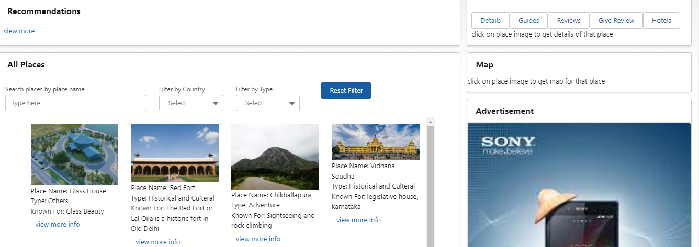
* You can search by entering place name and/or filter by selecting country name and/or type. In the below figure, house is entered in search bar and automatically it display places which contains house in the place name.  
    
  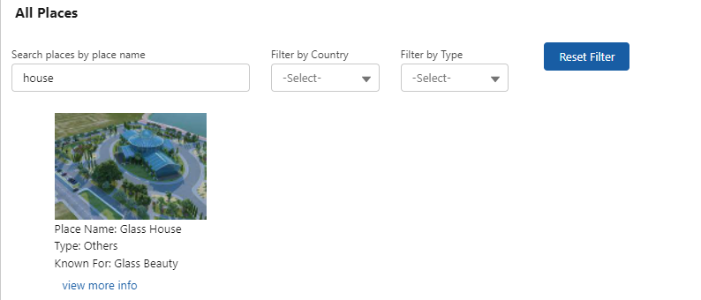

In the below figure India is selected as country name, and Adventure type is selected and automatically it display places which meets the criteria.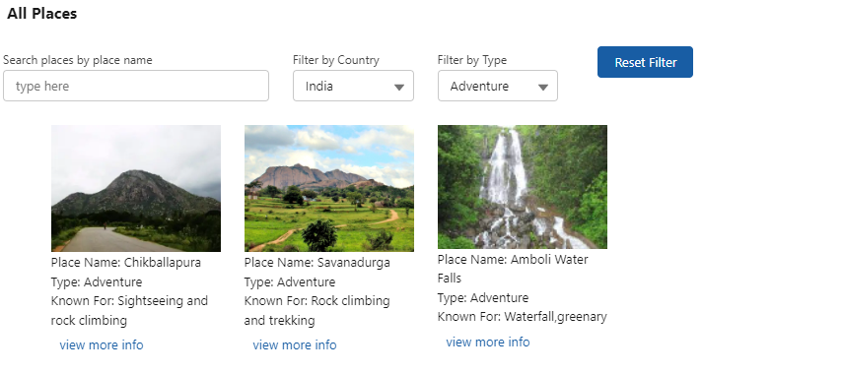  
  
  
In the above example if ch is entered in search bar, then it will display only places which meets above criteria and having ch in place name like below, if Reset Filter button is clicked then it will refresh the page  
  
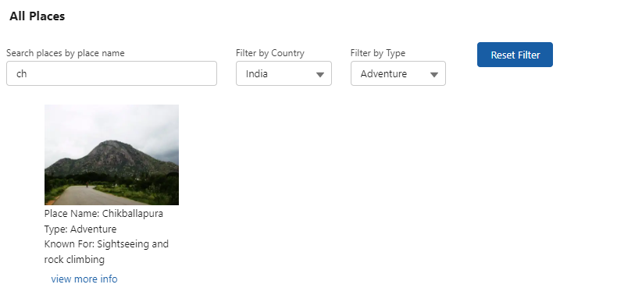

* If view more info is clicked then it will load details of that place like below  
    
  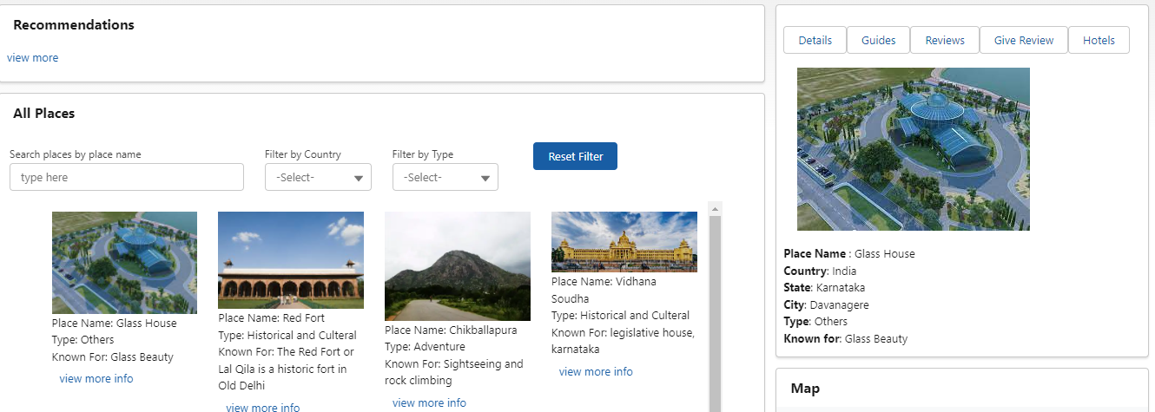  
    
  and map will be loaded for that place below details like below  
    
  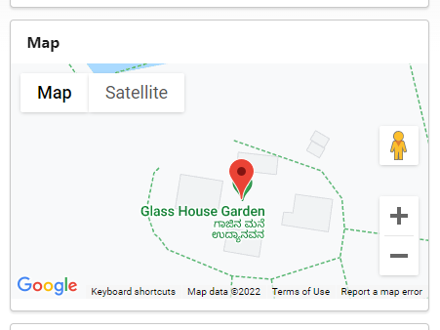  
    
    
  If Guides button is clicked then it will display guides available for that place like below  
    
  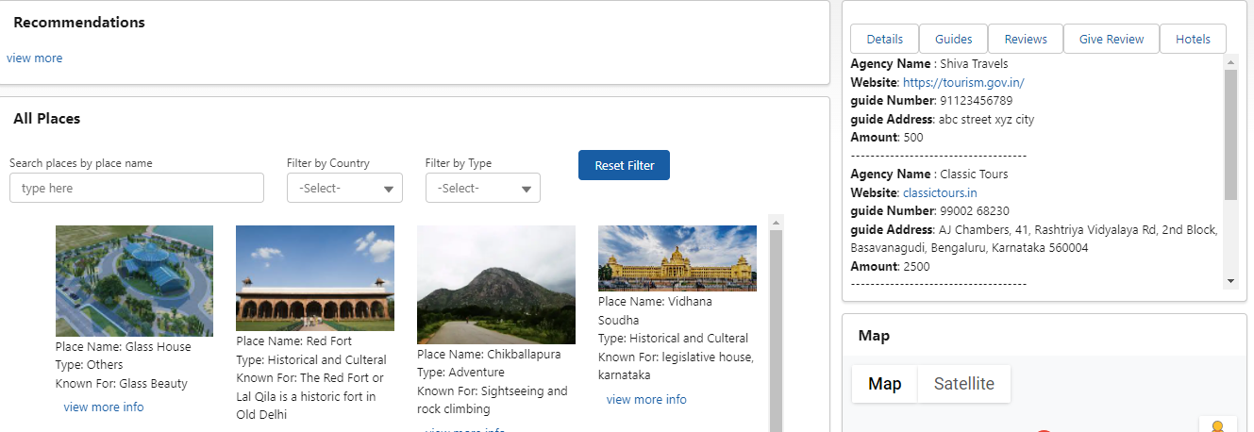  
    
  If Review button is clicked then it will display all reviews given by the user for that place along with Overall Ratings like below  
    
  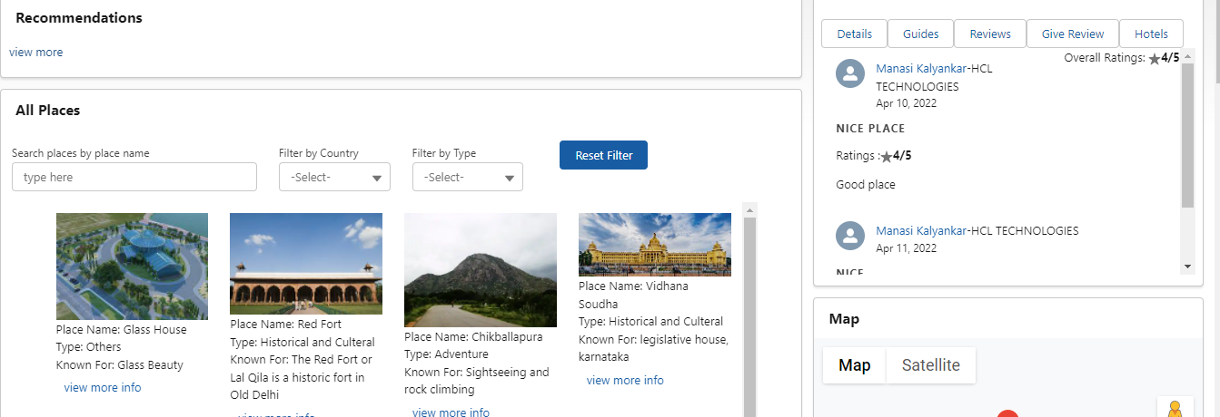  
    
  If Give Review button is clicked then you will be able to give review for that place like below  
    
  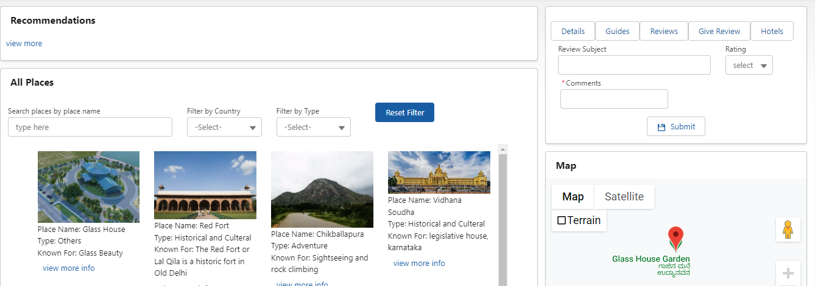  
    
    
  If Hotels button is clicked then it will display all hotels near to that place like below  
    
  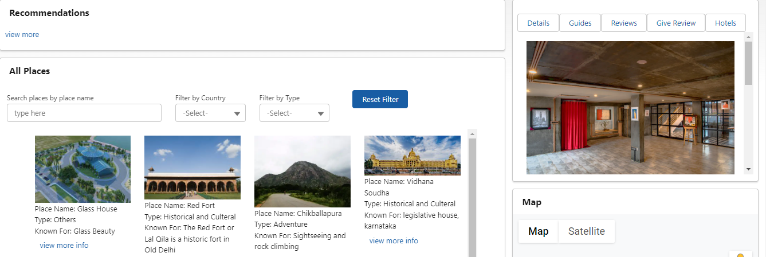
* Recommendations contains recently viewed places with most recently viewed places at top like below  
    
  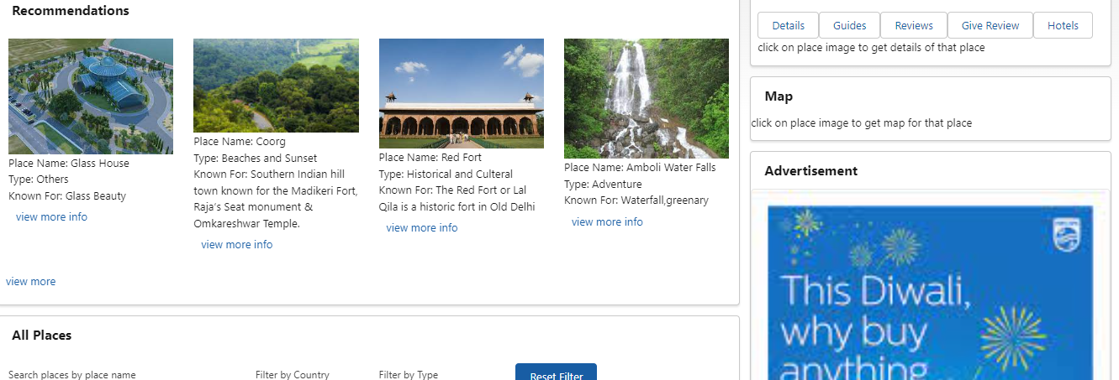  
    
    
    
  click on view more to view all recommendations and scroll down the recommendations side bar and click on view less to view less recommendations
* If you click on click here to view/download user manual at bottom then user manual will be opened in the new tab and you can download user manual from there  
  